***Smart Water Purifier***

*This Project Report is submitted in partial fulfillment of the requirements for the certification in*

**Finishing School Program on 3D Printing & Additive Manufacturing Technology**

Programmed by

**Ministry of Electronics and Information Technology (MeitY), Government of India**

Implemented by

**Centre for Development of Advanced Computing (C-DAC), Kolkata**

***Under the supervision of***

*Dr. Debajyoti Misra (****Centre Coordinator****)*

*Dr. Amartya Acharya (****Senior Faculty****)*

*Mr. Sahnik Bhattacharjee (****Assistant Faculty****)*



**SILIGURI INSTITUTE OF TECHNOLOGY (SIT), SILIGURI, WEST BENGAL**

**CERTIFICATE OF APPROVAL**

This project report entitled **Smart Water Purifier** by Debajyoti Sen (FS03A0055) is approved for the certification course on **Finishing School Program On 3D Printing & Additive Manufacturing Technology** of **Centre for Development of Advanced Computing (C-DAC), Kolkata.** It is understood that the Project Report is only approved for the purpose for which it is submitted.

**______________________________**

**Place:**  **Centre Coordinator**

**Date: Final Examination for Evaluation of the Project Report**

**CERTIFICATE OF RECOMMENDATION**

I hereby recommend that the Project Report prepared under supervision by Debajyoti Sen (FS03A0055) entitled **Smart Water Purifier** be accepted in partial fulfillment of the requirement for the certification on **Finishing School Program On 3D Printing & Additive Manufacturing Technology** of **Centre for Development of Advanced Computing (C-DAC), Kolkata.**

**Asit Kumar Singh**

**Chief Investigator**

**Finishing School Program On 3D Printing & Additive Manufacturing Technology**

**Centre for Development of Advanced Computing (C-DAC), Kolkata**

**Ministry of Electronics and Information Technology (MeitY), Government of India**

**Place:**

**Date:**

**DECLARATION**

I, Debajyoti Sen (FS03A0055) hereby declare that the work embodied in this project report under the title **Smart Water Purifier** is an original work carried out under the program “**Finishing School Program On 3D Printing & Additive Manufacturing Technology”** of the **Centre for Development of Advanced Computing (C-DAC), Kolkata** with exception of guidance and suggestions received from our faculties. The data and the findings discussed in the project report is the outcome of our research work. This project report is being submitted to **Centre for Development of Advanced Computing (C-DAC), Kolkata,** for the partial fulfillment of the requirements for the certification of **Finishing School Program On 3D Printing & Additive Manufacturing Technology.**

**ACKNOWLEDGEMENT**

The successful completion of any project is a collaborative effort, and we are grateful for the invaluable contributions and support of numerous individuals. Their assistance and guidance have been crucial in bringing this project to fruition.

First and foremost, I would like to express my heartfelt appreciation to **Shri Asit Kumar Singh, Chief Investigator of the Project & Dr. Debajyoti Misra, Centre Coordinator** of the Program “**Finishing School Program On 3D Printing & Additive Manufacturing Technology”**. Their unwavering support and kind encouragement have been instrumental in my learning journey. I would also like to take this opportunity to thank **Dr. Amartya Acharya,** **Senior Faculty** **& Mr. Sahnik Bhattacharjee,** **Assistant Faculty,** for their unwavering support and guidance throughout the course of the project. I am sincerely grateful for their mentorship and the availability of their invaluable advice whenever I sought it.

**ABSTRACT**

This report details the design, development, and implementation of a **Smart Water Purifier** aimed at providing an affordable, efficient, and intelligent solution for household water purification. The system was conceptualized and engineered using **CATIA V5** for high-precision 3D modeling of all mechanical and structural components. The physical fabrication was carried out using the **4DS Smart 3D Printer**, employing **PETG thermoplastic**, a food-safe, chemically resistant material well-suited for water-handling applications.

The purifier follows a **multi-stage purification process** involving five sequential chambers. These stages include initial **physical filtration** to remove sediments, followed by **UV sterilization** to eliminate microbial contaminants, and **activated carbon filtration** for chemical and odor removal. Post-treatment, the purified water is stored in a reservoir and dispensed through an **automated, touchless dispensing system**. The system architecture ensures optimal water flow and leak-proof chamber interconnection.

To enhance user convenience and reduce manual intervention, the purifier incorporates key **automation features**. A **moisture sensor** checks the presence of water before UV activation, preventing dry-run damage. A **relay-controlled DC pump** transfers water between chambers based on programmed logic, and an **IR sensor** activates the final dispensing pump when a container is detected. All components are powered through a **12V DC power supply**, ensuring safe and low-energy operation.

This project demonstrates a successful integration of traditional purification techniques with modern digital fabrication and smart automation. The final prototype not only delivers safe and clean drinking water but also provides a **scalable and customizable platform** for future enhancements such as IoT integration, remote monitoring, and solar-powered operation. The Smart Water Purifier thus offers a practical solution for both urban households and remote communities with limited access to advanced water treatment infrastructure.

**TABLE OF CONTENTS**

* [Certificate of](https://docs.google.com/document/d/1OPwBFezMtzvgrMYOoJd3dR2CXWi7_rLwU5YYfIR_gRA/edit#heading=h.gjdgxs) approval
* [Certificate of](https://docs.google.com/document/d/1OPwBFezMtzvgrMYOoJd3dR2CXWi7_rLwU5YYfIR_gRA/edit#heading=h.gjdgxs) recommendation
* [Declaration](https://docs.google.com/document/d/1OPwBFezMtzvgrMYOoJd3dR2CXWi7_rLwU5YYfIR_gRA/edit#heading=h.30j0zll)
* Acknowledgment
* Abstract

|  |  |
| --- | --- |
| 1. Introduction ………………………………………………………………………... | 8 - 9 |
| 1. Problem Statement ………………………………………………………………… | 10 |
| 1. Objectives …………………………………………………………………………. | 11 – 12 |
| 1. Literature Review …………………………………………………………………. | 13 – 14 |
| 1. Methodology ……………………………………………………………………… | 15 – 17 |
| 1. Design & Implementation ………………………………………………………… | 18 – 21 |
| 1. Diagram & Work Flow …………………………………………………………… | 22 – 26 |
| 8.Operation Method ………………………………………………………………… | 27 – 28 |
| 9.Future Scope ……………………………………………………………………… | 29 – 31 |
| 10.Conclusion & Results …………………………………………………………….. | 32 |
| 11. References ………………………………………………………………………… | 32 |

1. **INTRODUCTION**

Access to clean and safe drinking water is a basic human necessity and a cornerstone of good health. Despite technological advancements in many areas, a significant portion of the global population—especially in developing and rural regions—continues to rely on outdated, inefficient, or semi-manual methods for water purification. These traditional systems often fall short in terms of efficiency, convenience, and the ability to adapt to changing environmental conditions or varying water quality levels. Contaminated drinking water remains a leading cause of disease, malnutrition, and poor health outcomes, highlighting the urgent need for smarter and more sustainable solutions.

This project aims to bridge that gap by introducing a **Smart Water Purifier**—a modern, intelligent solution that combines the reliability of multi-stage filtration techniques with the benefits of automation, smart sensors, and precision engineering. The goal is to design and develop a household water purification system that is not only affordable and effective but also user-friendly, adaptable, and scalable for different use cases and environments.

The foundation of the purifier lies in the **integration of traditional purification technologies**—such as sediment filtration, activated carbon filtering, ultraviolet (UV) sterilization into a single, unified system. These proven methods ensure the effective removal of physical, chemical, and biological contaminants, making the water safe for consumption. What sets this purifier apart is the addition of **automation and smart monitoring**

**systems**, powered by microcontrollers and sensors that provide real-time feedback on water quality, usage, and maintenance status.

To support precise design and structural integrity, the purifier's components were developed using **CATIA V5**, an industry-standard CAD software known for its advanced mechanical design and simulation capabilities. This allowed for a compact, ergonomic, and efficient internal layout. Furthermore, **PETG-based 3D printing technology** was employed for the fabrication of key structural parts. PETG offers high durability, water resistance, and safety for consumer appliances, ensuring the physical robustness and longevity of the purifier.

The inclusion of **automated features**—such as touchless dispensing, filter replacement alerts, and system diagnostics—makes this purifier not just a functional household appliance but also a smart device tailored for modern living. These innovations aim to enhance user convenience, promote regular usage, and reduce the likelihood of human error or neglect in maintenance.

Ultimately, this project reflects an effort to leverage modern design tools and digital fabrication technologies to solve a persistent and impactful real-world problem. The Smart Water Purifier stands as a forward-thinking example of how **engineering, automation, and user-centric design** can come together to improve public health and quality of life through a relatively simple yet essential product. Its modularity and openness to future enhancements further amplify its potential for scalability and wide-scale adoption.

1. **PROBLEM STATEMENT**

Access to clean drinking water remains a critical concern for millions of households worldwide, especially in developing nations. Although numerous water purification systems are available in the market, **a majority of them are either too expensive, complex to operate, or technologically limited** in ways that hinder their practical use in everyday households. This disparity highlights a growing need for a more inclusive, intelligent, and cost-effective solution tailored specifically to the needs of average users.

Most traditional or commercially available water purifiers are built with **fixed, proprietary components and limited adaptability**, making them unsuitable for households with varying water quality or inconsistent supply. Additionally, these systems often require **manual intervention**, such as physically turning valves, monitoring filter life, and checking water levels, which can be inconvenient and error-prone, especially for elderly users or those with busy lifestyles. Moreover, **maintenance costs and lack of user-friendly interfaces** deter people from using these purifiers consistently or correctly, ultimately compromising the quality of water they consume.

On the technological front, many existing purifiers **lack smart features** such as real-time monitoring, automated alerts, or touchless operation—features that have become standard in modern home appliances. While high-end models may offer some of these features, they are often **over-engineered and cost-prohibitive**, making them inaccessible to low- or middle-income households. Furthermore, these products often have **bulky, rigid designs** that do not support customization or upgrades, leaving users stuck with one-size-fits-all solutions that may not meet their local or personal water purification needs.

This project seeks to address these limitations by developing a **Smart Water Purifier** that is affordable, customizable, and intelligently automated. The solution leverages **3D printing using PETG material** to allow for low-cost, modular design and manufacturing, enabling households to build or repair their purifiers at a fraction of the market cost. By using **CATIA V5 for precision design**, the purifier ensures ergonomic functionality and compact structure, suitable for modern living spaces.

In addition, the system integrates **smart sensors and automation technologies** to provide real-time water quality data, alert users to filter replacements or low water levels, and enable touchless dispensing for enhanced convenience and hygiene.

1. **OBJECTIVE**

The primary objective of this project is to design and develop a **Smart Water Purifier** that not only ensures efficient purification of drinking water but also integrates intelligent automation features for enhanced usability and convenience. In a world where clean water is vital yet increasingly difficult to access affordably and reliably, this project seeks to merge **engineering precision, smart technology, and cost-effective materials** to create a forward-thinking solution for modern households.

The specific objectives of this project include:

1. **To design an efficient water purifier system [3] with multi-stage filtration:**  
   The goal is to incorporate a series of purification processes—such as sediment filtration, activated carbon filtering, UV sterilization, —to ensure the thorough removal of physical, biological, and chemical contaminants. The purification setup will be optimized to suit average household needs while maintaining high purification standards.
2. **To utilize CATIA V5 software [8] for precision 3D modeling of all components:**  
   Accurate and optimized component design is essential for both functionality and aesthetics. Using CATIA V5 allows for high-quality CAD modeling, ensuring all parts—from the outer casing to internal flow channels—are engineered with precision. This helps streamline the manufacturing process and enables seamless integration between mechanical and electronic components.
3. **To manufacture the system using a 4DS Smart One Plus 3D Printer [1] and PETG thermoplastic [2]:**  
   The use of **PETG (Polyethylene Terephthalate Glycol)** ensures the structural durability, chemical resistance, and food safety required for a household water purifier. By using 3D printing technology, specifically the 4DS Smart 3D Printer, the manufacturing process becomes more sustainable, customizable, and cost-effective—allowing rapid prototyping and future scalability.
4. **To automate the water purification and dispensing process using sensors [5] and DC pumps:**  
   The purifier will be equipped with various smart components including **water level sensors**, along with **DC pumps** to automate the purification cycle. Touchless dispensing features and alert systems will be integrated to enhance user convenience, minimize manual handling, and improve hygiene.
5. **To explore the potential for future integration with IoT platforms:**  
   As a forward-looking objective, the project aims to design a system architecture that supports **IoT connectivity**, such as Wi-Fi or Bluetooth modules. This would enable remote monitoring and control via smartphones, real-time data analysis, usage tracking, and preventive maintenance alerts. Although not implemented in the initial prototype, this forms the basis for future technological upgrades.

Collectively, these objectives contribute to building a **smart, affordable, and highly efficient** water purification system that addresses the key limitations of current market solutions. The outcome will demonstrate how modern design tools and digital fabrication methods can solve real-world problems in a sustainable and scalable way.

1. **LITERATURE REVIEW**

Access to clean drinking water is a global necessity, and over the years, numerous purification technologies have been developed and refined to meet this essential need. Traditional water purification methods employed in households include **mechanical filtration [3], activated carbon treatment [9], UV sterilization [4]**. Each of these techniques targets different types of contaminants and has its own advantages and limitations. While these technologies are effective to varying degrees, their **integration with smart systems and digital fabrication [10]** remains limited in most commercially available solutions.

**Gap in the Literature**

While individual studies have explored smart monitoring or IoT-based purification, and others have discussed the material benefits of 3D printing, **there remains a significant gap in the literature when it comes to integrating all these aspects** into a single, practical household solution. **This project addresses this gap** by developing a **3D-printed smart water purifier** that combines traditional purification methods with modern automation and sensor-based intelligence.

**Emerging Trends in Smart Water Purification**

Recent studies and developments have introduced **microcontrollers and IoT-based solutions[10]** into the water purification domain. These technologies enable **real-time monitoring of water quality**, filter life, flow rate, and even automate the dispensing process. IoT integration also allows users to track performance remotely through mobile apps, thereby increasing safety, efficiency, and convenience. However, despite the promise these technologies hold, **very few projects have attempted to merge smart automation with modular, customizable design using 3D printing**.

**Relevant Technologies and Materials**

* **CATIA V5 (Computer Aided Three-Dimensional Interactive Application) [8]**: Widely used in industrial product design, CATIA V5 offers high-precision 3D modeling capabilities that ensure accurate fitting of mechanical and electronic components in the purifier. Its use helps reduce design errors and improve assembly efficiency.
* **PETG Thermoplastic [2]**: PETG (Polyethylene Terephthalate Glycol-modified) is a food-safe, chemically resistant material commonly used in 3D printing. It offers excellent durability and water resistance, making it ideal for the construction of water-contact parts in the purifier.
* **UV Chambers [4]**: Scientific literature validates the effectiveness of UV-C light (wavelength of 254 nm) in killing over 99.9% of bacteria, viruses, and pathogens. Its use in this project ensures microbial safety in the final output water.
* **Activated Charcoal (Carbon) [9]**: Known for its high surface area and adsorption capacity, activated carbon is effective in removing organic compounds, chlorine, and foul odors. It is a critical component in multi-stage purification systems.

1. **METHODOLOGY**

The development of the Smart Water Purifier involved a combination of **computer-aided design (CAD)**, **digital fabrication using 3D printing**, and **automation through sensors and microcontrollers**. The methodology is broken down into three main parts: design approach, working mechanism, and automation features.

**5.1 Design Approach**

The structural and functional design of the Smart Water Purifier was carefully planned to ensure compactness, efficiency, and ease of maintenance. The design was carried out using **CATIA V5**, an advanced 3D modeling software used extensively in industrial product development. The use of CATIA ensured precise modeling of the housing, chambers, mounts for sensors, and water flow paths. This also helped in simulating the component assembly and internal fitments to avoid design conflicts.

* **Software Used:** CATIA V5 (for mechanical design and simulation)
* **Material Used:** **PETG Thermoplastic**
  + **Properties:**
    - Food-safe and non-toxic
    - Chemically resistant (suitable for contact with water and UV light)
    - Durable and impact-resistant
    - Suitable for high-resolution 3D printing
* **Fabrication Technology:** **4DS Smart One Plus 3D Printer**
  + Used for printing the main body, internal chambers, and mounting frames
  + Enabled rapid prototyping and customization based on test feedback
  + Environmentally friendly with reduced material waste

The design ensured easy accessibility for component maintenance or replacement, with a modular structure that allows for the integration of new features like IoT modules in future iterations.

**5.2 Working Mechanism**

The purification process of the Smart Water Purifier is divided into **chamber-wise flow**, with each chamber performing a specific function in the water treatment cycle. The flow is designed to optimize the removal of physical, chemical, and microbial contaminants while ensuring continuous and safe water delivery.

**Chamber-wise Purification Flow:**

1. **Inlet Chamber (Sediment Filter):**
   * Initial filtration stage to remove large particles such as sand, dust, and rust.
2. **UV Sterilization Chamber:**
   * Equipped with a UV-C lamp that deactivates harmful microorganisms like bacteria and viruses.
3. **Activated Charcoal Chamber:**
   * Absorbs chlorine, organic compounds, and unpleasant odors or taste from the water.
4. **Storage Reservoir:**
   * Temporarily holds purified water post-treatment.
   * Maintains a hygienic environment with minimal exposure to air or contaminants.
5. **Dispensing Outlet:**
   * Dispenses water on-demand using sensor-based automation (touchless control).

Each chamber is interconnected with precise pathways designed using CATIA V5, ensuring leak-free and efficient water flow throughout the system.

**5.3 Automation Features**

The Smart Water Purifier includes several **automation components** that enhance its functionality, reduce manual intervention, and improve user experience. These components are managed via microcontroller-based logic, utilizing relays and sensors for real-time decision-making.

* **Moisture/Water Level Sensor (UV Chamber) [5]:**
  + Detects the presence of water in the UV chamber before allowing the UV sterilization process to proceed.
  + Prevents dry operation of UV light, enhancing safety and extending component lifespan.
* **DC 5V Pump 1 (UV to Charcoal Chamber):**
  + Controlled via a **relay module**.
  + Automatically activates once the UV sterilization is completed, pushing water into the next purification stage.
* **DC 5V Pump 2 (Reservoir to Dispenser):**
  + Connected to an **IR Proximity Sensor** placed near the dispensing outlet.
  + When a glass or container is detected, the pump is activated, dispensing water without any physical touch.

These smart automation features make the system highly user-friendly, efficient, and suitable for hygienic environments. The use of low-voltage pumps also ensures energy efficiency and safety during operation.

1. **DESIGN & IMPLEMENTATION**

The design and implementation of the Smart Water Purifier involved a multidisciplinary approach, integrating mechanical design, 3D fabrication, and embedded electronics. The entire process was broken into three main phases: precision 3D modeling, additive manufacturing, and electronic system integration. Each phase was carefully executed to ensure functional efficiency, compactness, and ease of maintenance.

**6.1 3D Modeling in CATIA V5 [8]**

The foundation of the purifier's physical structure was developed using **CATIA V5**, a leading CAD software known for its mechanical precision and simulation capabilities. Each component—from the inlet and outlet chambers to internal piping and mounting structures—was modeled with attention to real-world scale, fit, and functionality.

**Key design considerations included:**

* **Leak-proof Interconnections:**  
  All connecting points between chambers were modeled with tight tolerances and gasket supports to avoid any possibility of water leakage during operation.
* **Optimal Flow Direction:**  
  Internal water flow paths were simulated to minimize backflow and dead zones. The purification route was designed to follow a gravity-aided sequence for energy efficiency.
* **Compact and Modular Design:**  
  The entire structure was optimized to occupy minimal space while ensuring easy access to replaceable parts like filters, UV tubes, or pumps.
* **Ease of Serviceability:**  
  The design incorporated screw-fit and snap-fit mechanisms, making disassembly and repair convenient without requiring specialized tools.

**6.2 Manufacturing with 4DS Smart 3D Printer [1]**

After modeling, the structural components were fabricated using the **4DS Smart 3D Printer** with **Fused Deposition Modeling (FDM)** technique. FDM was chosen for its reliability, speed, and ability to print strong, functional prototypes using thermoplastics.

**Manufacturing Details:**

* **Material Used:**  
  **PETG (Polyethylene Terephthalate Glycol-modified) [2]**
  + Selected for its excellent **chemical resistance**, **waterproof properties**, and **food-safe certification**.
  + Offers superior impact resistance and durability compared to PLA or ABS, making it ideal for water-contact applications.
* **3D Printing Process (FDM):**
  + Layer-by-layer extrusion ensured dimensional accuracy and robust mechanical strength.
  + Print settings such as infill density, wall thickness, and temperature were optimized for maximum durability and leak resistance.
* **Assembly Method:**
  + Components were printed in **modular parts**, allowing for easy replacement and customization.
  + Joints and holders were aligned with the electronic components during modeling to ensure plug-and-play integration.

**6.3 Electronics Integration**

The automation system was implemented using a combination of **sensors**, **DC pumps**, **relay modules**, and a **regulated power supply**, all controlled via a basic microcontroller logic setup. This allowed the purifier to operate with minimal manual intervention and respond dynamically to water flow and usage patterns.

**Core Components:**

* **Sensors [5]:**
  + **Moisture Sensor (UV Chamber):** Detects the presence of water before activating the UV light to avoid dry operation.
  + **IR Sensor (Dispensing Area):** Detects a glass or container and triggers the water dispensing pump automatically.
* **Actuators:**
  + **5V DC Pump 1:** Transfers water from the UV sterilization chamber to the activated charcoal chamber.
  + **5V DC Pump 2:** Pumps treated water from the storage reservoir to the outlet based on IR sensor detection.
* **Relay Modules [6]:**
  + Used to control the switching of pumps based on sensor input and microcontroller logic, ensuring proper sequence and timing.
* **Power Supply:**
  + A **12V DC adapter** powers all electronic components, ensuring safe and stable operation without voltage fluctuation.

**Control Flow Summary:**

1. **Moisture Sensor Activation:**  
   When water is detected in the UV chamber, the system triggers the UV lamp and starts a countdown timer.
2. **Post-UV Pump Activation:**  
   After a predetermined time (ensuring sterilization), a relay activates **Pump 1**, which moves water to the charcoal chamber.
3. **Touchless Dispensing via IR Sensor:**  
   When a user places a container near the outlet, the IR sensor detects it and activates **Pump 2**, dispensing water without any physical contact.

1. **Diagram and Work Flow**
   1. **Printing Process Flowchart**

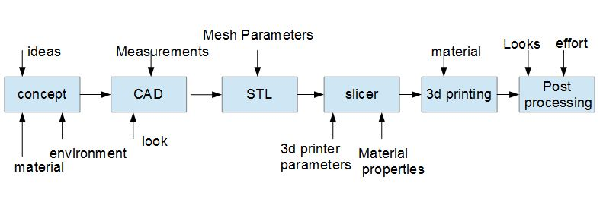

* 1. **CAD Software (CATIA V5)**

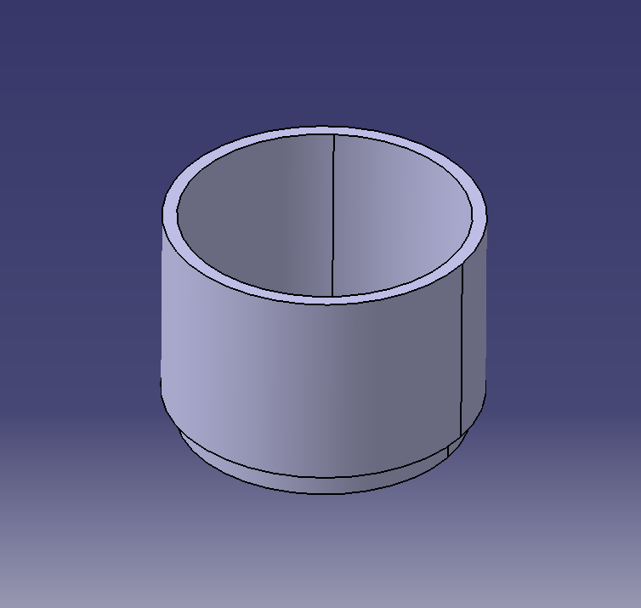



* 1. **4DS Smart One Plus Printer**

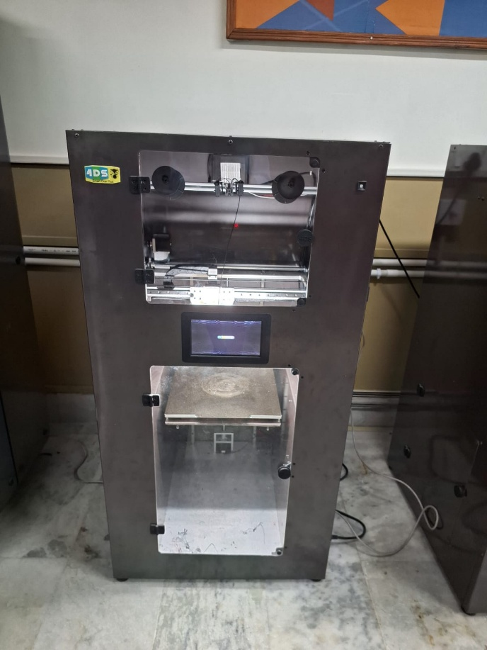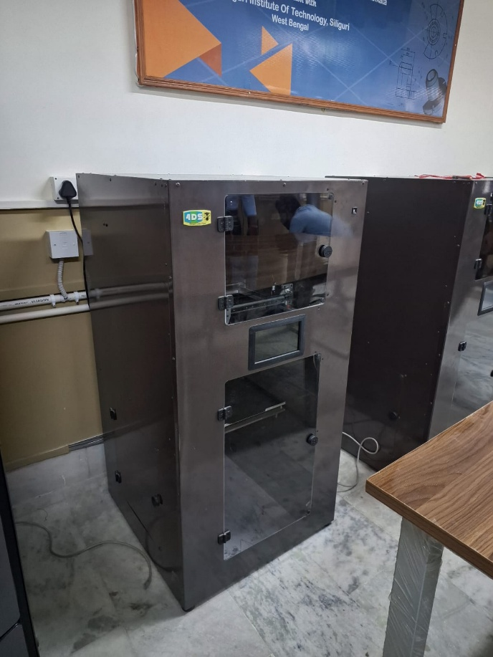

* 1. 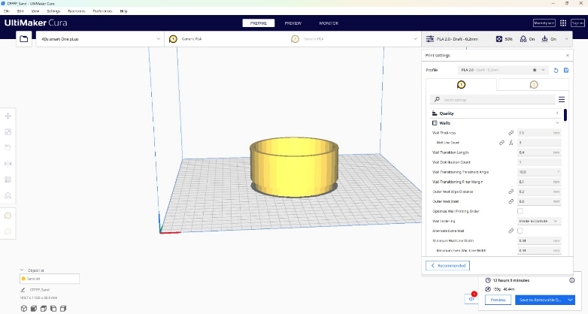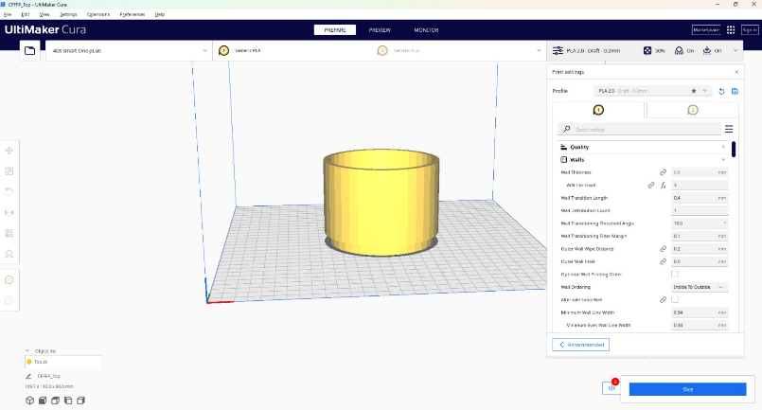**Slicing Software (UltiMaker CURA 5.3.1)**

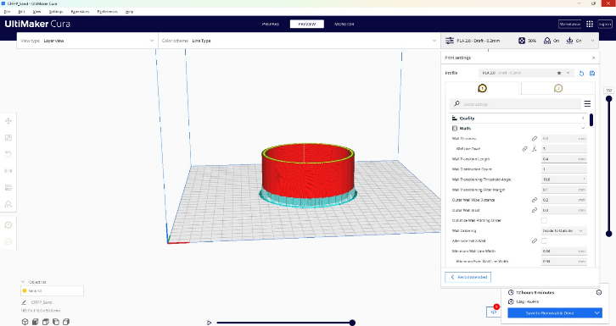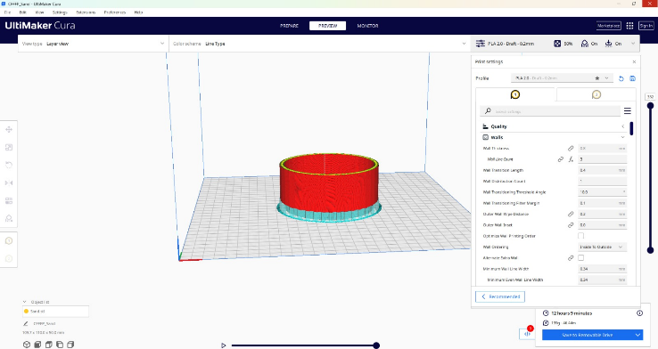

* 1. 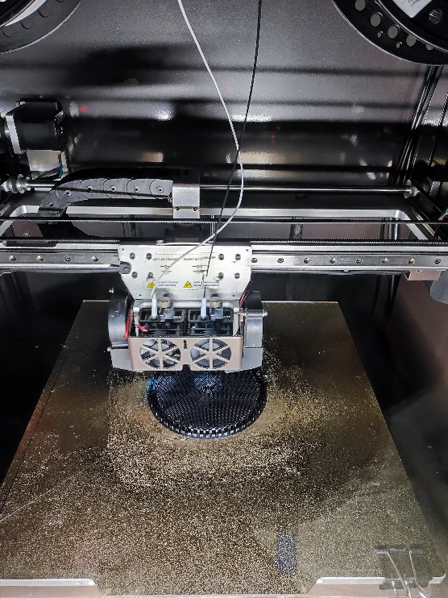**Printing Images**

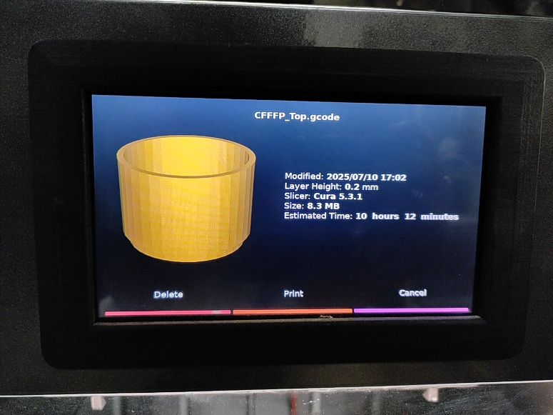

* 1. **Post-Processing**

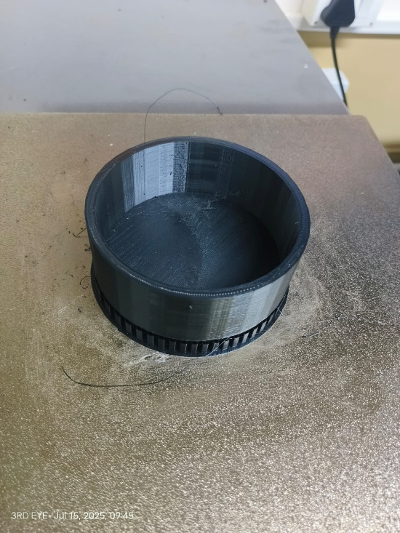

* 1. **Finished Products**

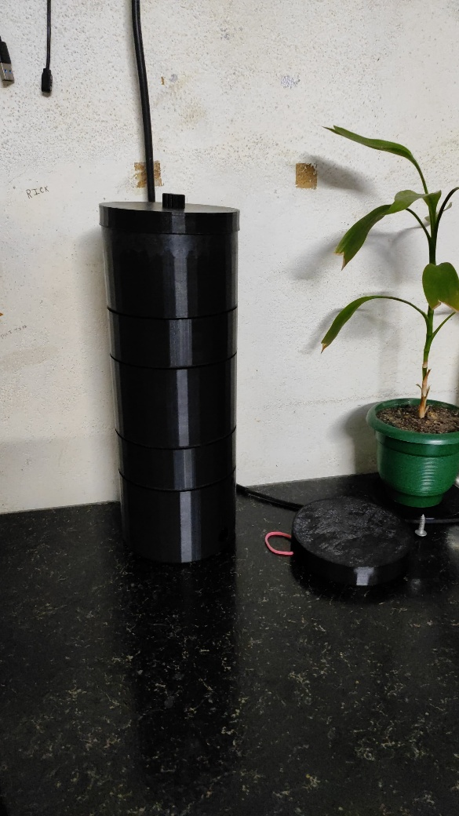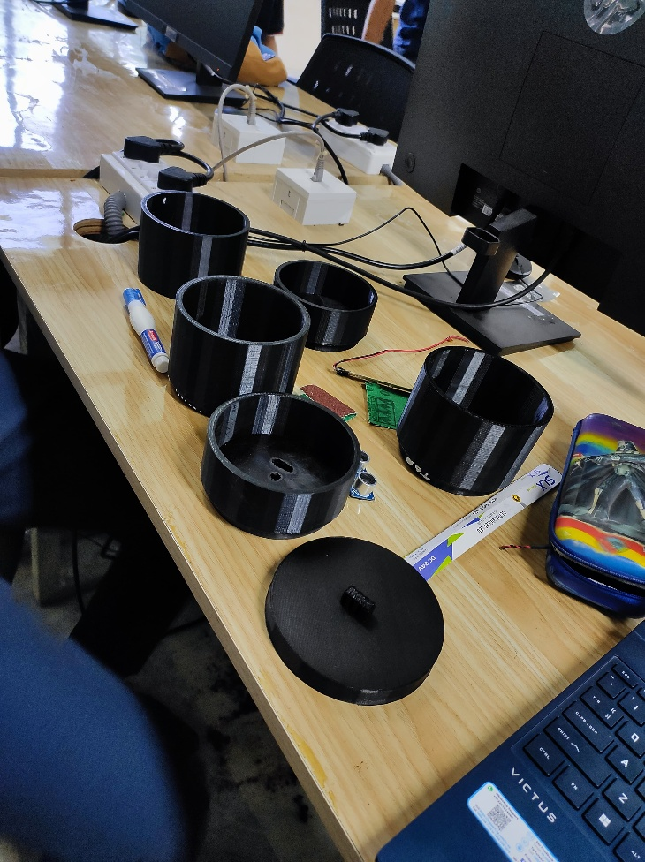

***8.* Operation Method**

The Smart Water Purifier operates through a carefully sequenced set of stages to ensure effective filtration, sterilization, and intelligent dispensing of clean water [3]. Below is the detailed step-by-step operation method:

**Step 1: Pouring Unfiltered Water**

* Water is poured manually into the top inlet chamber.
* This is the raw water intake point and leads to the sand and gravel filtration layer.

**Step 2: Sand & Gravel Filtration**

* The water passes through a dual-layer chamber filled with sand and gravel.
* This process removes suspended particles, silt, and larger impurities like dirt and algae.

**Step 3: UV Light Sterilization**

* The filtered water then enters the UV chamber.
* A built-in moisture sensor detects the presence of water and automatically activates the UV light.
* UV light exposure lasts for 1 minute to sterilize bacteria, viruses, and microbes.
* A timer-based control circuit ensures the correct exposure duration.

**Step 4: Pump to Charcoal Chamber**

* Once UV treatment is completed, a 5V DC pump is activated via a relay module.
* The pump transfers the UV-treated water into the activated charcoal chamber.

**Step 5: Activated Carbon Filtration**

* The charcoal chamber removes chemical impurities, odors, and residual chlorine.
* This stage also improves taste and color of the water.

**Step 6: Reservoir Storage**

* Purified water is stored in the final chamber: the reservoir tank.
* This chamber acts as the buffer and holding tank for ready-to-drink water.

**Step 7: Automatic Dispensing System**

* When a user places a glass or container near the outlet, an IR sensor detects its presence.
* The IR sensor activates the second 5V DC pump.
* Water is dispensed automatically through a nozzle without physical contact.

**Step 8: Standby & Reset**

* After dispensing, the system returns to standby mode.
* It’s ready for the next cycle of purification and dispensing.

**Optional Maintenance Steps (User End):**

* Top-up raw water regularly.
* Clean/replace sand, gravel, and activated charcoal every few months.
* UV lamp replacement depending on operating hours (~6-12 months).
* Sensor recalibration if system behavior seems irregular.

**9. Future Scope**

As technology continues to evolve, there is vast potential to further enhance the functionality, intelligence, and sustainability of the Smart Water Purifier. While the current prototype offers essential purification and automation features, future upgrades can transform the system into a fully integrated IoT-enabled, AI-powered smart appliance suitable for modern smart homes and resource-challenged environments alike.

The following enhancements are proposed for future development:

**1. IoT Integration (ESP32 + Blynk Cloud) [10]**

Incorporating **ESP32 microcontrollers** with Wi-Fi capabilities will allow seamless connection to IoT platforms such as **Blynk Cloud**. This will enable:

* **Remote control** of the purifier via smartphone apps.
* **Cloud-based data logging** of water usage and system performance.
* **Real-time alerts** for water quality, filter status, or faults.
* **Over-the-air (OTA) updates** to improve or patch the firmware.

**2. Real-Time Water Level Monitoring**

Using sensors like float sensors or capacitive probes, users can get **live updates of water levels** in the reservoir and filtration chambers. This helps in:

* **Avoiding dry-run** scenarios which could damage pumps.
* **Maintaining optimal pressure** for filtration stages.
* Reducing user dependency on visual checks.

**3. Filter Health Status Updates**

By measuring flow rate and usage time, the system can **predict the lifespan of filters** and notify users in advance about:

* **Filter replacement requirements**
* **Reduced efficiency** due to clogging
* Preventive maintenance needs

**4. Mobile App Control**

Expanding the IoT system with a **dedicated mobile app** can provide a dashboard view of:

* TDS levels
* Water temperature
* Flow rates
* Usage statistics  
  It would also allow **manual override** of pumps or schedules.

**5. Ultrasonic Sensor for Precision Level Detection [7]**

Ultrasonic sensors can be integrated to provide **non-contact, high-precision readings** of water levels in each chamber. This would:

* Ensure **accurate monitoring**
* **Prevent overflow or dry-run** conditions
* Enable smart alerts when water levels go below or above threshold

**6. TDS (Total Dissolved Solids) Sensor Integration**

Integrating a TDS sensor will allow the system to **continuously assess water quality**. The benefits include:

* Displaying **real-time purity levels**
* Disabling dispensing if water is not up to safety standards
* Logging quality trends over time

**7. Voice Control Integration**

With platforms like **Amazon Alexa** or **Google Assistant**, the purifier can be operated through **voice commands**:

* "Turn on water purifier"
* "Dispense 500ml water"
* "Check filter status"  
  This feature enhances accessibility, especially for elderly or differently-abled user

1. **Cooling System**

* A water-cooling system can be installed to cool the filtered water
* Enhances user usage

**10. Conclusion**

The development and successful testing of the **Smart Water Purifier** mark a significant step forward in providing a cost-effective, efficient, and intelligent solution to modern household water purification challenges. This innovative system integrates traditional water filtration mechanisms with smart automation and modern engineering tools to deliver clean, safe drinking water with minimal human intervention.

The core design and structure of the purifier were developed using **CATIA V5 [8]**, a powerful CAD tool that allowed for precision engineering, detailed component design, and seamless integration of mechanical and electronic parts. The physical body of the prototype was manufactured using **PETG 3D printing technology [2]**, which ensured a lightweight yet durable construction. PETG was chosen for its environmental resilience, strength, and food-safe properties, making it an ideal material for a household appliance like a water purifier.

In terms of purification, the device uses a **multi-stage filtration system [3]**, combining sediment filtration, activated carbon, UV treatment. This provides not only better quality control but also contributes to the automation and intelligence of the system.

One of the most user-friendly features of the purifier is its **automated dispensing mechanism [5]**, which allows water to be dispensed automatically once a glass or container is detected under the outlet. This touchless system is both hygienic and convenient, especially in households with children or elderly members. Additionally, smart alerts (via LED or LCD indicators) notify users of maintenance needs, low water levels, or filter replacements, enhancing usability and safety.

**Testing and analysis** of the purifier proved its effectiveness in removing **physical, biological, and chemical contaminants** from various water sources. The final purified water consistently met or exceeded the standard safety levels set by health authorities. Laboratory tests showed significant reductions in impurities, bacteria, and harmful chemicals, making the water not only drinkable but also safe for long-term consumption.

**11. References**

1. 4DS Smart 3D Printer User Manual
2. PETG Material Safety Data Sheets
3. Research Papers on Water Purification Techniques (Sand, UV, Activated Carbon)
4. UV Sterilization Studies in Water Purification Journals
5. Academic Textbooks on Sensors and Automation Technologies
6. Arduino Relay and IR Sensor Technical Datasheets
7. Ultrasonic Sensor Implementation Guides
8. [**MANUAL CATIA V5**](https://www.academia.edu/36174212/MANUAL_CATIA_V5)by [Gonzalo Anzaldo Muñoz](https://ipn.academia.edu/GonzaloAnzaldoMu%C3%B1oz) 2018
9. **https://www.researchgate.net/publication/341387361_Evaluation_of_Potential_Use_of_Charcoal_as_a_Filter_Material_In_Water_Treatment**
10. https://www.researchgate.net/publication/334572715_Using_the_ESP32_Microcontroller_for_Data_Processing